# Successful login

Location: /var/log/ secure

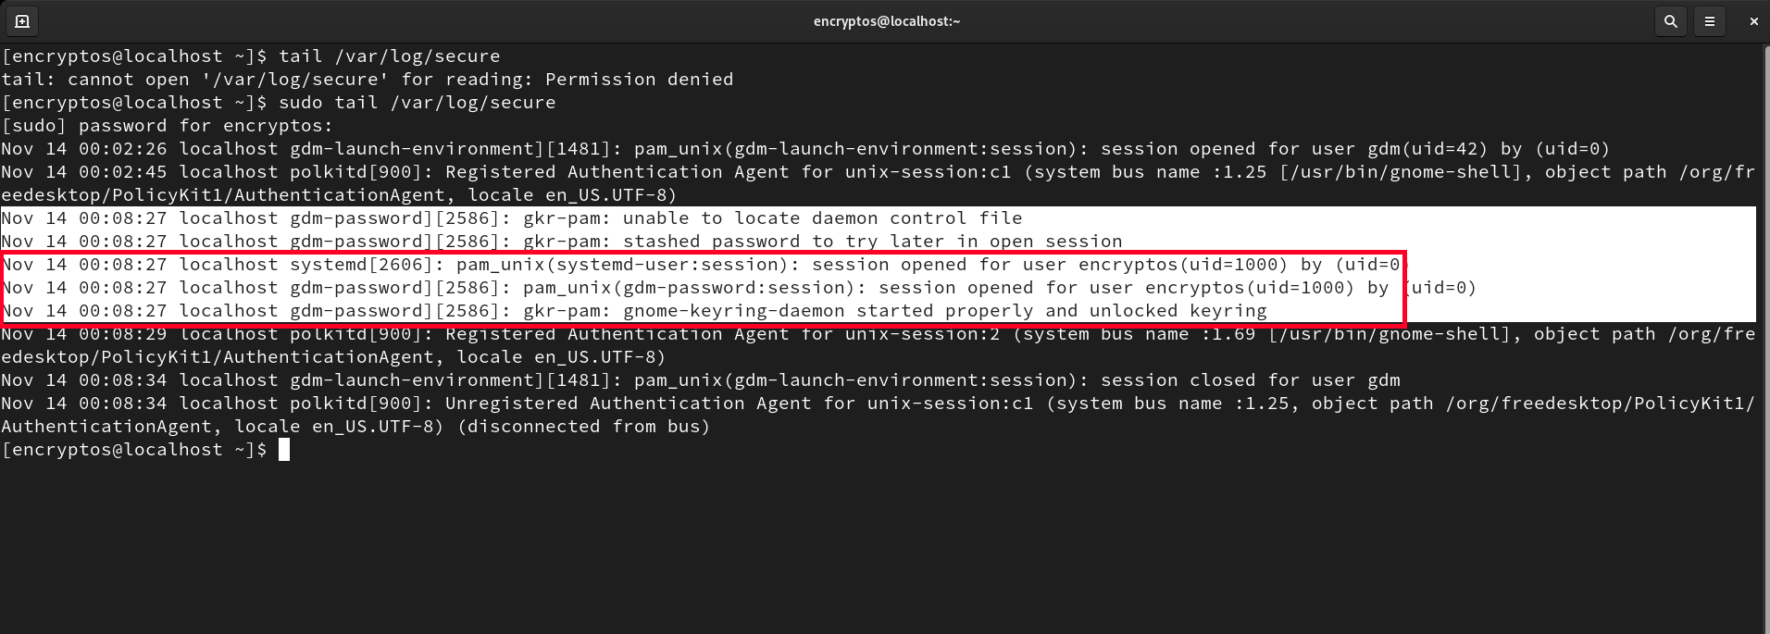

# Failed Login

Location: /var/log/ secure

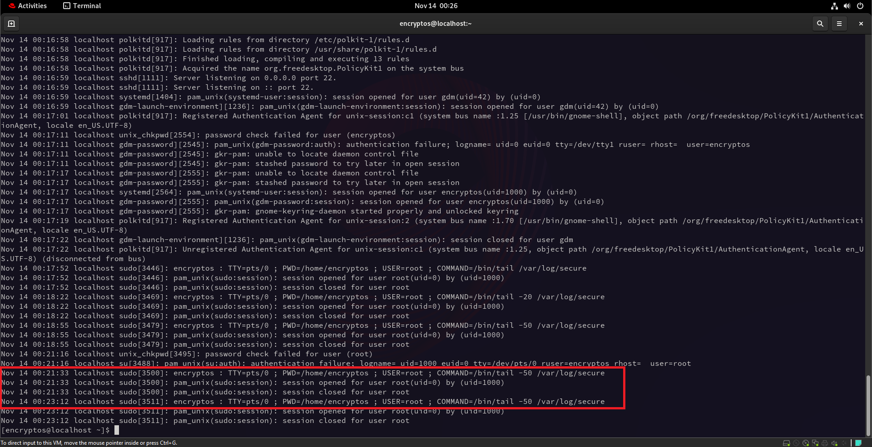

# Session opened for user root



# Software Install Log

Location : /var/log dnf.log

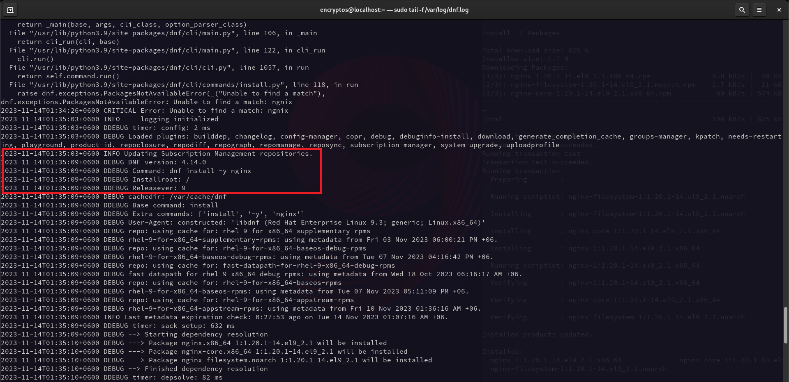

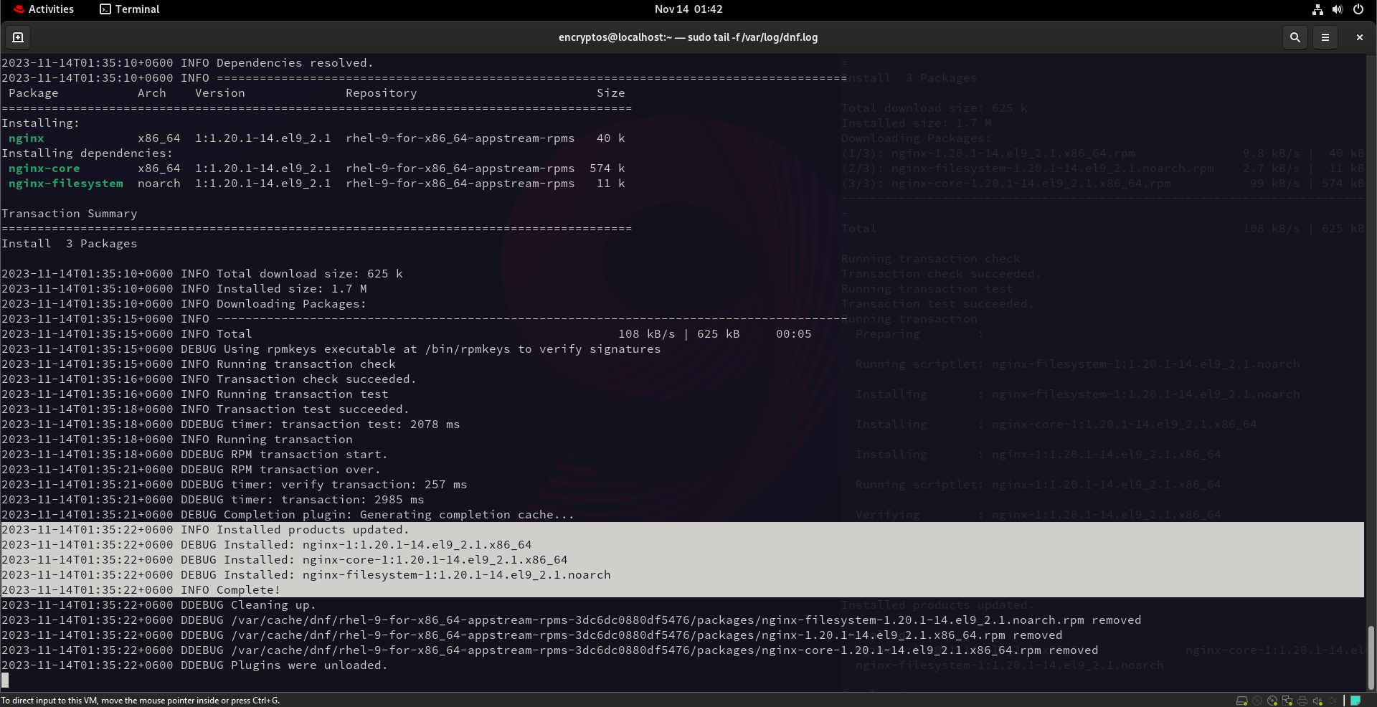

# Software uninstall Log

Location : /var/log dnf.log

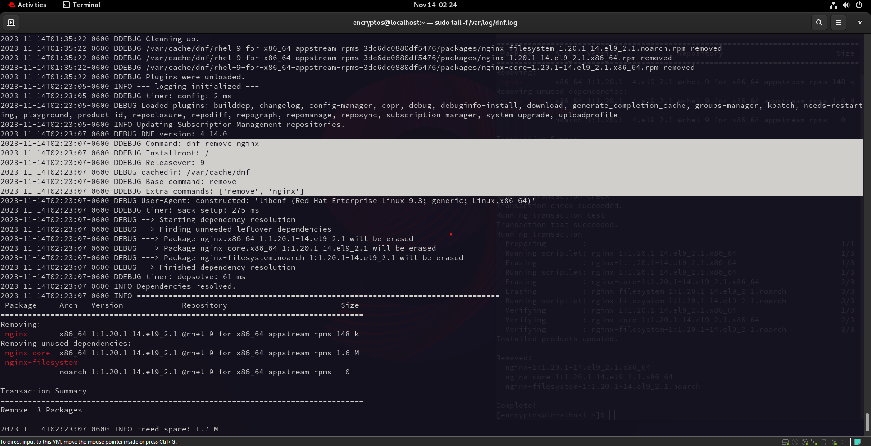

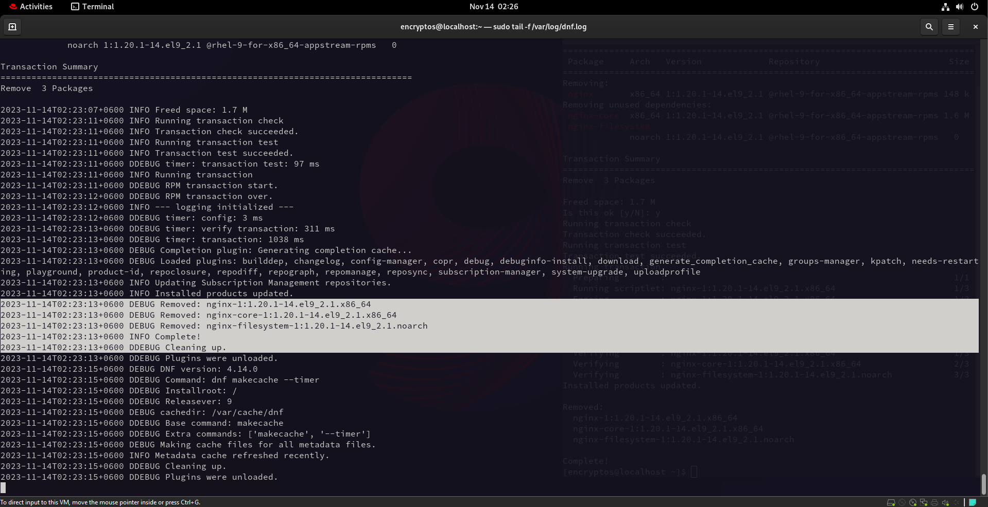

# System time changed

Location: /var/log message

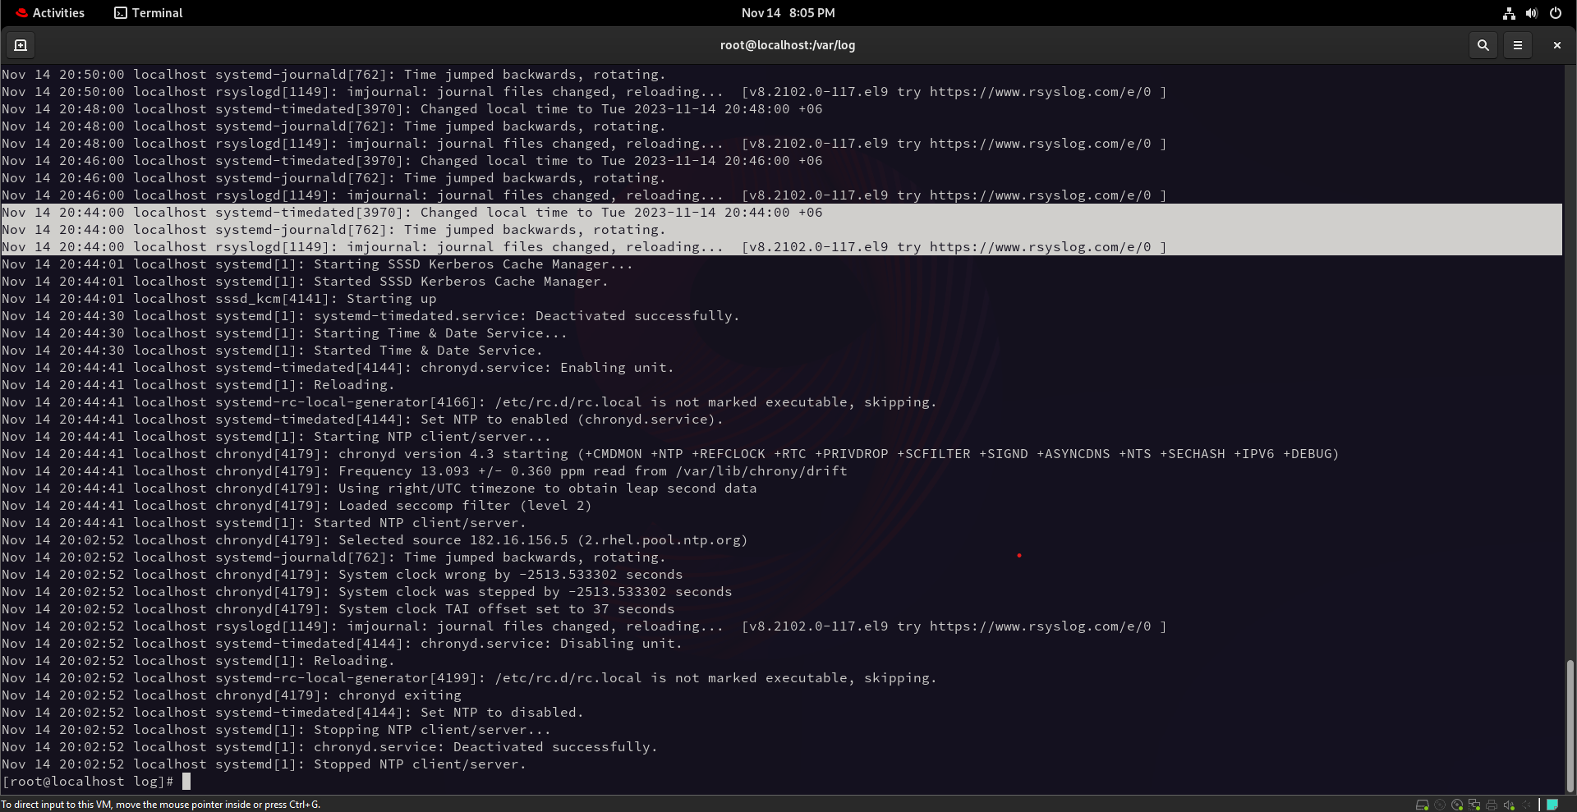

# User creation

Location : /var/log/ secure

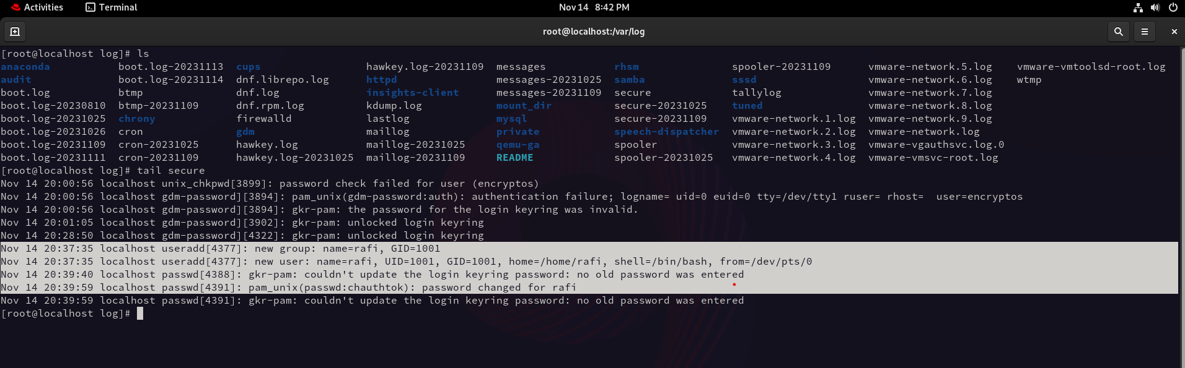

# User deletion

Location : /var/log/ secure

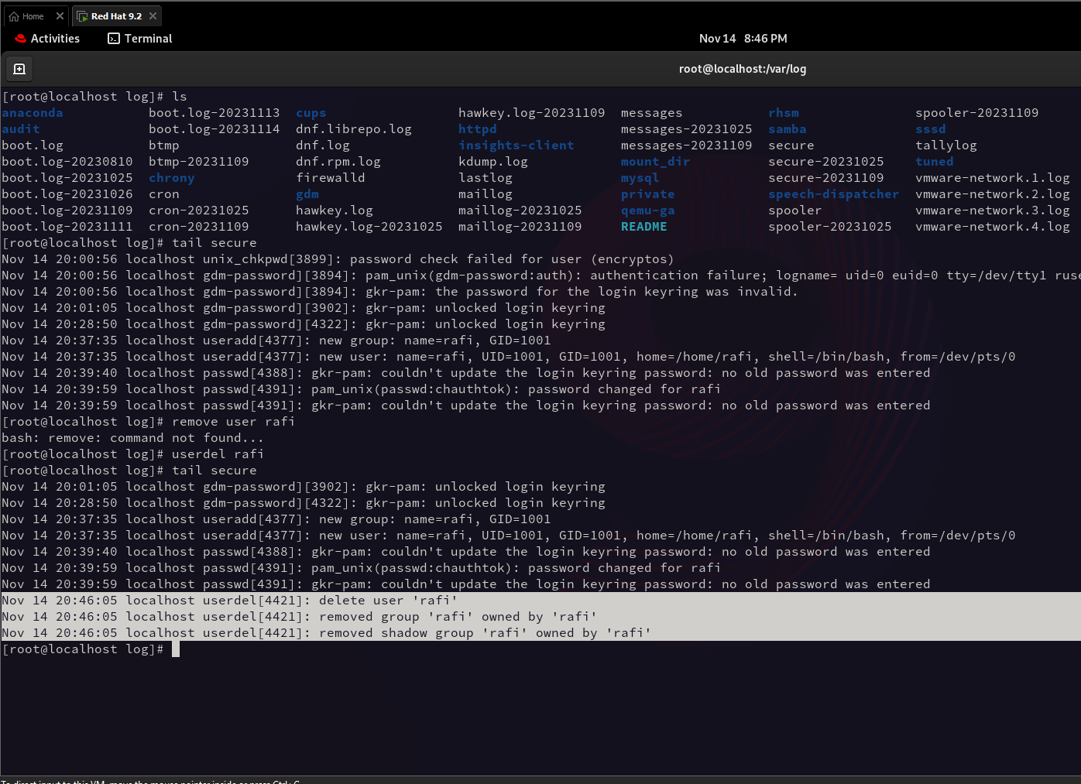

# Change user

Location : /var/log/ secure

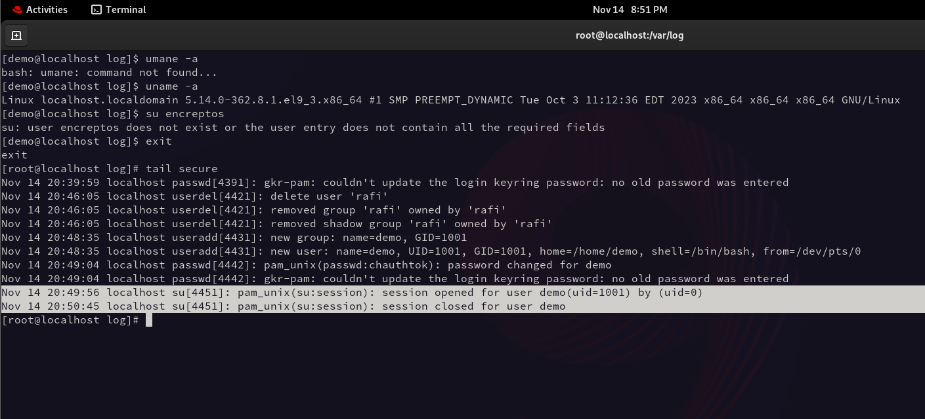

#User Password Change

Location : /var/log/ secure

